08-2017

Sent to NLM300’s in the following units.

498 – San Mateo – Redwood City
502 – East Bay
503 – Palo Alto
506 – San Francisco
507 – Silicon Valley
550 – Santa Cruz

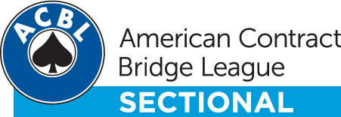
My ACBL Join Now

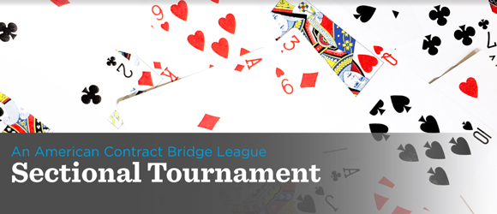
Dear Carl,
You are invited to play in the Palo Alto Non-Life Master Sectional. Don’t miss this great opportunity to earn silver points in this tournament that is limited to Non-Life Masters with fewer than 300 Master Points. Mark your calendars and sign up now!
· Saturday November 4, 2017. Games at 10AM and 2:30PM
· 2 single session stratified pairs. Stratified Sections: 49er, 199er, 299er
· Snacks Provided and Box Lunches for sale for $10.00 (Please order at time of registration)
· Capacity is 45 tables which we expect to fill, so register early.
Palo Alto Bridge Center, 423 A Stierlin Road, Mountain View, CA 94043
Tournament Chair and Partnerships: Alan Cummings. Email: alan.cummings@Stanford.edu
See attached flier for additional tournament and lunch information.
Online Registration preferred. To go to the signup page, CLICK HERE, or go to: www.paloaltobridge.com - Events- Non-Life Master Sectional.

Let’s make this event another one of the terrific opportunities our unit provides to enjoy the great game of bridge. We hope to see you there.

Your current rank is Diamond Life Master.
You have 999.99 masterpoints.
If you would like to unsubscribe immediately and stop receiving emails from American Contract Bridge League click here.

