The tournament took place on Sat. 5/5/18. We had 34 tables in the morning (9:30 start time) and 29 tables in the afternoon (2:00 start). 2/3 of the attendees played in both sessions. 51 people responded to this survey which is a great response rate.

Question 1: Which sessions did you play?

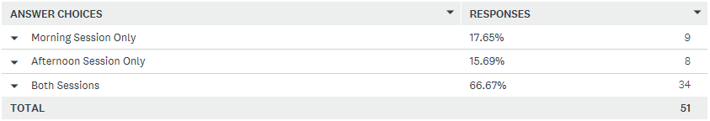

Question 2: Please check all the stratifications you played (Check all that apply)

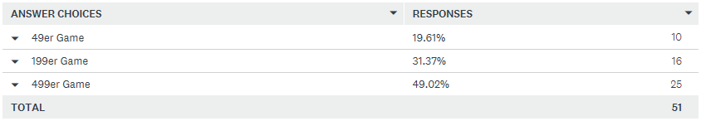

Jim’s thoughts: Being a mentor in some of Kathy Harper’s beginner classes, I’ve seen her encourage new students to practice what they’ve learned by coming to games. Recognizing that newer players may be fearful/lack confidence, she has especially told her students that tournaments are “safer than games”. Directors have also supported our promotion, being sure to include players with fewer points. I believe having 20% of our attendees in the 49er bracket is a good sign that we’re connecting and supporting this demographic.

Question 3: Based on the May 5 event, how likely would you be to recommend a Unit 503 Non Life Master’s event to another bridge player seeking a Non Life Master event?

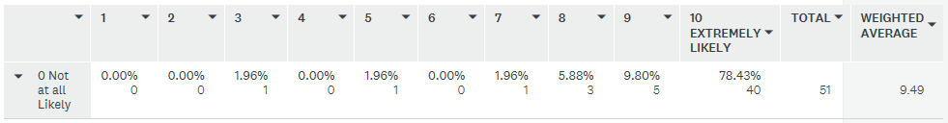

Question 4: What are the reasons for your response?

Summary of responses (note that all 44 individual responses will be shown beneath the survey’s questions – also note that question 8 looks at some specific aspects of the event)

- People had fun. Our unit really emphasizes the importance of having fun and it’s clear that people enjoyed themselves.
- The people who attended are nice. Again it’s so good to see another of our unit’s key values reflected in the event.
- The event was very well run/managed/organized. This was the strongest positive we received covering how the directors ran the game/event to the behind the scenes operations.
- We have a great venue. A wide range of comments all support the point that we create a good environment – our pleasant/clean/roomy facilities, good parking, the food we provide, etc.

Question 5: How well did the May 5 event meet your expectations?

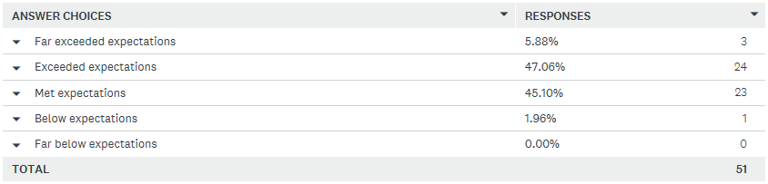

Summary of responses

- 92% said that we met or exceeded their expectations. This, along with the responses in questions 3 and 4 show that we’ve created a successful game plan for this kind of tournament and are able to execute it.

Question 6: What was the one most important reason you played in this event?

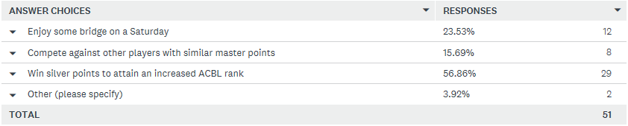

Summary of responses

- While a bit more than half said they wanted to get silver points to help advance their rank, a quarter of the attendees just wanted to enjoy some bridge on a Saturday. 1/6 of the players wanted to compete against others with a similar number of master points.

Jim’s thoughts: Unfortunately Pianola showed people earned black points, not silver. Some attendees were disappointed because they “didn’t earn silver” or because they thought that they had to attend both events to earn silver and we didn’t advertise that – neither of which is true. The unit needs to work with Pianola to make sure they show the correct color points are awarded.

Question 7: Please rate the pace of play per round for this event

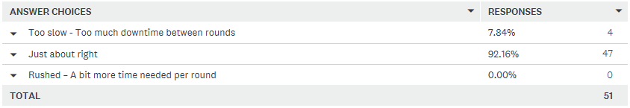

Jim’s thoughts: I believe a well-paced event contributes a lot to how “fun” and “well run” it is. Please refer back to questions 3 and 4.

Question 8: Please rate the following aspects of the event

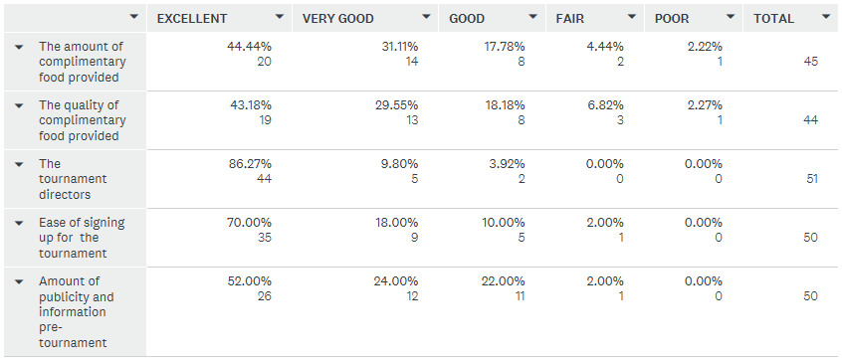

Summary of responses

- We do a really good job providing food before each game. Over 90% of the attendees rated the quantity and quality between good and excellent. Over 40% felt the amount and quality was excellent while less than 10% thought the quantity and quality was fair or poor.
- Our players love our directors. Every respondent answered this question and the rating can’t get much better than this.
- We also did a very good job reaching out to our community and informing them of this event and a great job in enabling them to sign up for this tournament.

Question 9: Which is the best format for future Unit 503 Non Life Masters events?

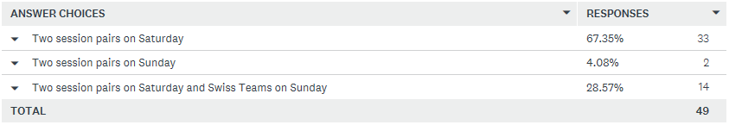

Jim’s thoughts: The numbers speak for themselves. Just over 2/3 of the participants prefer our current one day two session pairs event. Almost 30% would like to see pairs on Saturday and Swiss on Sunday, but I don’t know if this is a big enough percentage to justify holding the two day event.

Question 10: What other suggestions do you have to help improve future Unit 503 Non Life Masters events?

Summary of responses (note that all 24 individual responses will be shown beneath the survey’s questions after the responses given for question 4)

- Most of the responses were actually compliments instead of suggestions for improvement. With one exception, the rest of the comments were pretty much one of a kind, some worth taking note of.
- The one area we can improve on is the sign-in process. Crowding and traffic flow was a concern with suggestions such as having more people/tables for sign-in, better spacing between sign-in and IFES lunch purchase tables (including the possibility of using the area just outside the front door if weather permits), and using signage to direct people.

Individual Responses for Question 4: What are the reasons for your response? (to Question 3 - Based on the May 5 event, how likely would you be to recommend a Unit 503 Non Life Master’s event to another bridge player seeking a Non Life Master event?)

Nice players. Good parking. Clean and pleasant place. Good lunch available and affordable. Great people at the club.

It was well organized and everything went smoothly

A lot of fun

Large turnout and pleasant facility. Favorable start times at 9:30 AM and 2:00 PM. Good food before game and snacks during game. Well-run game by directors. Games started promptly. Sufficient time allocated to play hands - not rushed.

Very well run tournament, convenient location/parking.

Generally well run. I would have appreciated a short break around the middle of each session.

I thought it was well run, and a good way to accumulate silver points.

The game was well organized and enjoyable.

It was well run.

I have a good experience

Well run, good people, lots of fun. Also, good food.

well run; good food

Well run tournament, good hosts and players

thanks everyone for putting the event together; very enjoyable, well organized and by the number of those participating, it was well advertised and well attended, Greg C

Lots of tables, very hospital environment, well run game

Tournament was fine. I was yucky.

well run, nice snacks and lunch,

Everything ran very smoothly and on time. Snacks were good. Facility was roomy and clean. Very well organized.

Well organized Friendly people

Well organized, good breakfast snacks, started on time.

I thought the tournament was well run and fun. I would play in another one. I hope it made some money.

Very well run game

We were put in the wrong section—didn’t notice til after!

Well managed, excellent venue, nice people

Fun and friendly group. Extremely well organized!

You may receive silver!

It was relatively quiet, minimal waiting between rounds, and a nice lunch. Things ran like clockwork. The people that played were very nice, too.

The possibility to play interesting hands and to see your achievement in comparison with other players

Great club, well run event.

Nice facility and great game.

You had a great turn out, good competion, lots of help, great game management

It was a very well run tournament with great organization. Everything went very smoothly, Well done!

Well run and fun.

Unaware of the alternatives and it was a well-run event

Pleasant venue, good lunch, game well run.

It was a well run tournament

had fun

Well-run and attended, and PABC is the best (facility and directors!)

Well organized. Lunch OK. Well attended. Extra points but thought they were going to be silver. Pianola says points are black. If silvermpoints I would have rated “extremely likely.”

Well run event, but tough competition.

It was well organized. Ran smoothly

Very well organized game.

Well run event and very pleasant

We did not realize we were in the 199er and would have wanted to be int the 499er where we always play. Did not realize that until looking at the results!

Individual Responses for Question 10: What other suggestions do you have to help improve future Unit 503 Non Life Masters events?

Please do this kind of thing for gold points.

More meat on sandwich

None

I think this time is well run and stay on time. Last November, the game was running late and tables were messed up (results reported for us belong to a different pair).

Do not know how you would make it better.

799er or 999ers too?

all went very well, no suggestions, thx gjc

Good job guys!

No suggestions-no complaints

maybe two sign up tables or more people working that table

None

None. Thx for organizing it. The survey is a great idea!

I think it was well organized and well attended. Good job!

Prevent entrance crowding by placing the sign ups for food and tables well apart. If weather permits, use the outdoor area near the entrance for lunch purchases. Use hanging signage for location of A,B,C areas to find tables more easily.

none. This was well done.

More impartiality of the directors

These games are great. Keep up the outstanding job of hosting the NLM games.

continue to have lots of volunteer help on hand to keep things moving

I liked the 9:30 am start time. The second session could probably start at 1:30

Give Silver points for a single event.

Life masters should not be allowed to play.

A little more emphasis on keeping up the pace, including having a slow pair finish a board afterwards. I saw several pairs waiting around a few times.

I have no suggestions. But didn’t we pay for the “complimentary” food?

Allow people to know which section they are in. We always do much better against 499ers or open players than against 199ers, even though that is our category.

